Where Is a Ton of CO2 Decided? A Process Mining Analysis of Business Travel Emissions
Process Intelligence Challenge – Sustainability Project: Decarbonizing Travel
Alejandro Arias Rojas, Mariangel Arias Alfaro, Kendal Trejos Cubero, Gabriel Montero Apú, and Sebastian Alfaro Arias
Business Informatics, Western Campus (Sede de Occidente, Recinto de Tacares), University of Costa Rica, Alajuela, Costa Rica
Abstract.
Keywords: Process Mining · Celonis · Sustainability · Scope 3 Emissions · Business Travel · Conformance Checking

1 Introduction

1.1 Context
The case analyzed in this paper describes a technology company that has committed to reaching Net Zero carbon emissions by 2030 [1]. Its internal analysis indicates that most of its Scope 3 emissions, that is, indirect emissions that occur in the value chain and outside the company’s own operations [2], come from employee business travel. The travel booking process is decentralized: each employee books flights, trains, cars and hotels on their own, historically prioritizing cost and convenience rather than carbon efficiency. The case was adapted for academic purposes and does not represent the internal policies or data of a real organization [1].
To evolve this process, the company defined three improvement pillars, which are used throughout this paper to link findings with recommendations: (P1) integrating carbon metrics, by incorporating emission data directly into the booking and approval workflow; (P2) enhancing automation, by increasing the automation rate of policy checks so that sustainable choices are made consistently; and (P3) driving transparency, by creating a clear carbon accounting system to track, measure and report performance [1].
Process mining is well suited to this problem because it reconstructs how a process is actually executed from the event data recorded by information systems, instead of relying on how the process was designed [3,4]. In this case, the event log makes it possible to relate each emission to the moment of the process in which it is decided: booking, approval, changes, or the trip itself.

1.2 Business Questions
The challenge asks, at a minimum, for the current emissions profile, a comparison with the technology industry and between regions, the identification of hotspots, recommendations for travel policies, and the integration of the analysis into a long-term sustainability strategy [1]. Based on these requirements and on a first exploration of the data, the team formulated eight business questions:
- What is the current total carbon footprint of the travel program?
- How do regions compare in carbon efficiency per trip, and which region offers the greatest reduction potential?
- Which routes and modes of transport are low-cost quick wins, and which ones require long-term investments?
- Is there a relationship between out-of-policy trips and higher emissions?
- Which business units and travel purposes concentrate the highest emissions?
- Which process variants are associated with longer cycle times, cancellations or changes, and how do they relate to emissions and costs?
- How reliable is the spend-based emission estimate (Spend_CO2e) compared with the activity-based calculation?
- Does the approval step filter out-of-policy trips, and which validations could be automated?
Questions 7 and 8 were proposed by the team. For each question, an explicit hypothesis was formulated before the analysis.

1.3 Contribution and Structure
The main contribution of this work is to show, with process mining techniques, where emissions are decided in the travel process and which process controls could reduce them. The paper is structured as follows. Section 2 describes the methodology and tools. Section 3 presents the datasets, the data model and an overview of the process. Section 4 reports the analysis of the business questions. Section 5 discusses the recommendations linked to the three pillars, and Section 6 concludes the paper.

2 Methodology and Tools

2.1 Approach
The analysis followed a question-driven approach inspired by the PM² process mining project methodology [5], organized in three phases: (i) data and process understanding, in which the datasets were loaded, related and validated, and the as-is process was discovered; (ii) analysis, in which each business question was answered by testing an explicit hypothesis; and (iii) interpretation, in which every finding was linked to one or more of the improvement pillars. All figures obtained in Celonis were cross-checked against the original CSV files.

2.2 Tools
The main tool was Celonis (Academic Alliance license) [6]. The four datasets were uploaded to a data pool, related in a data model and analyzed in a Studio analysis with the following components: the Process Explorer and Variant Explorer for process discovery, the throughput time component for cycle times, OLAP tables with KPIs written in PQL to compare groups of trips, and a dashboard that summarizes the main indicators. Four PQL resources were particularly useful:
- Custom dimensions with CASE WHEN, to create groupings that do not exist in the data, such as the departure region or the booking lead time.
- Pull-up (PU) functions, such as PU_FIRST, PU_LAST and PU_COUNT, which bring information from the event log to the trip level, for example the timestamp of the first booking or of the first departure.
- The GLOBAL operator, to express each group as a share of the total trips, emissions or costs.
- Timestamp comparisons between activities, used to check the order of the process against business rules (conformance checking).
Microsoft Excel was used in the first stage of the project for exploratory pivot tables (questions 1 and 3).

2.3 Definitions
Table 1 lists the definitions adopted by the team, which apply to the whole paper.
Table 1. Definitions adopted in the analysis.
Concept | Definition
Trip emissions | Transportation_CO2e + Hotel_CO2e (kg CO2e). Spend_CO2e is not added, since it is an alternative, spend-based estimate of the same impact.
Out-of-policy trip | OutOfPolicy = Yes. The policy requires booking flights 14 days in advance, cars 7 days and trains 3 days.
Departure region | Region of the departure country: North America (US, MX), Europe (DE, ES), Asia (CN, JP), Oceania (AU), Latin America (BR) and Africa (ZA).
Booking lead time | Days between the first Book Mode of Transportation and the first departure (Take Departure Flight, Take Departure Train or Pickup Rental).
Cycle time | Days between the first Book Mode of Transportation and the last Expense Reimbursement of a case.

3 Data and Process Understanding

3.1 Datasets
The challenge provides four related datasets and a data dictionary, all extracted from the travel management system [1]. Table 2 summarizes their granularity and role. The trip identifier (TripID) links all tables and is the case identifier of the event log. The event log covers the period from 1 December 2023 to 23 June 2025 and contains 34 different activities.
Table 2. Datasets of the challenge.
Dataset | Rows | Granularity | Role
Trip_Data_With_Emissions | 87,053 | One row per trip | Master table: locations, purpose, policy, business unit, costs and emissions
Transportations_Data_With_Emissions | 99,925 | One row per transport leg | Mode and class of each leg, cost and emissions
Trip_Event_Log | 895,366 | One row per event | Activity table (case, activity, timestamp, order)
Trip_Event_Attributes | 87,053 | One row per trip | Context of deviations (reasons for changes, cancellations, delays) and process code

3.2 Data Model
In the Celonis data model, Trip_Data_With_Emissions acts as the central table (one record per trip) and is related through TripID to the event log, the transportation legs and the event attributes. The activity table is Trip_Event_Log, with TripID as case identifier, EventName as activity, EventTimestamp as timestamp and StepOrder as sorting column. The data dictionary was used only as a reference and was not loaded.
Two properties of the model required special care. First, KPIs at trip level and at leg level cannot be combined in the same table: when this happens, Celonis computes them on the leg table and repeats the trip values once per leg, producing impossible results (for example, more than 100% of total emissions). Second, a KPI that refers to the event log repeats trip values once per event, which is on average 10.3 events per case. For this reason, leg-level indicators are always computed in separate tables, and event-log information is brought to the trip level with PU functions.

3.3 Process Overview
Fig. 1 (left) shows a simplified view of the discovered process with its main path. All 87,053 trips start with Book Mode of Transportation and Submit Travel Request; 83,940 trips (96.42%) reach Travel Request Approved, while 3,113 trips (3.58%) end after the request without being approved. A total of 83,749 trips (96.20%) end with Expense Reimbursement. Around this main path, the complete map contains deviation activities such as cancellations, changes, delays, missed flights, itinerary edits and trip extensions.
Celonis identifies 402 variants (Fig. 1, right). The most frequent variant covers 35% of the cases (30,304 trips), the five most frequent variants cover 57.35%, and the ten most frequent cover 65.8%. The cycle time between the first booking and the last expense reimbursement has an average of 22.9 days and a median of 24.4 days.
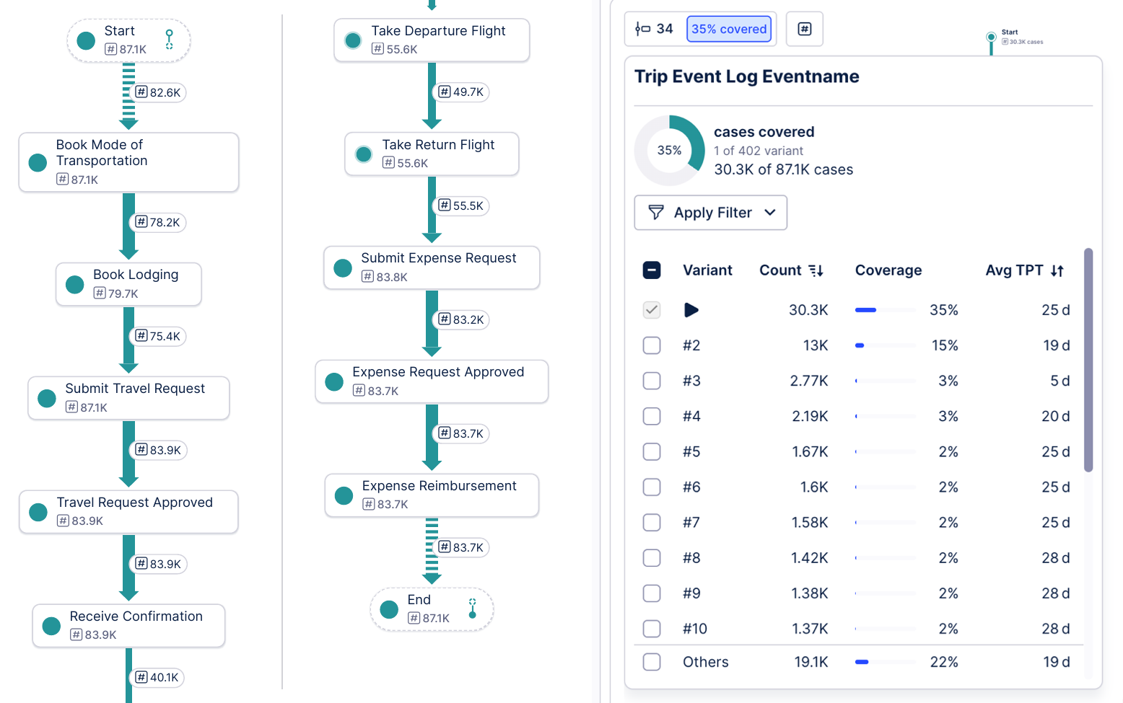
Fig. 1. Simplified process map with 10 of the 34 activities (left) and process variants (right) discovered in Celonis.

4 Analysis of the Business Questions

4.1 Q1: Emissions Profile
Hypothesis H1. Transport, and in particular air travel, concentrates most of the carbon footprint.
In the data, the total footprint of the travel program is 233,211,160.73 kg CO2e (233,211 t CO2e), with an average of 2,679 kg per trip. Transport accounts for 226,715,208.63 kg (97.21%) and hotels for 6,495,952.10 kg (2.79%). Within transport, flights generate 99.33% of the emissions. These indicators are the first row of the dashboard built in Celonis (Fig. 2), which also shows the distribution of transport emissions by mode, the share of trips and emissions by region, and the average emissions by booking lead time.
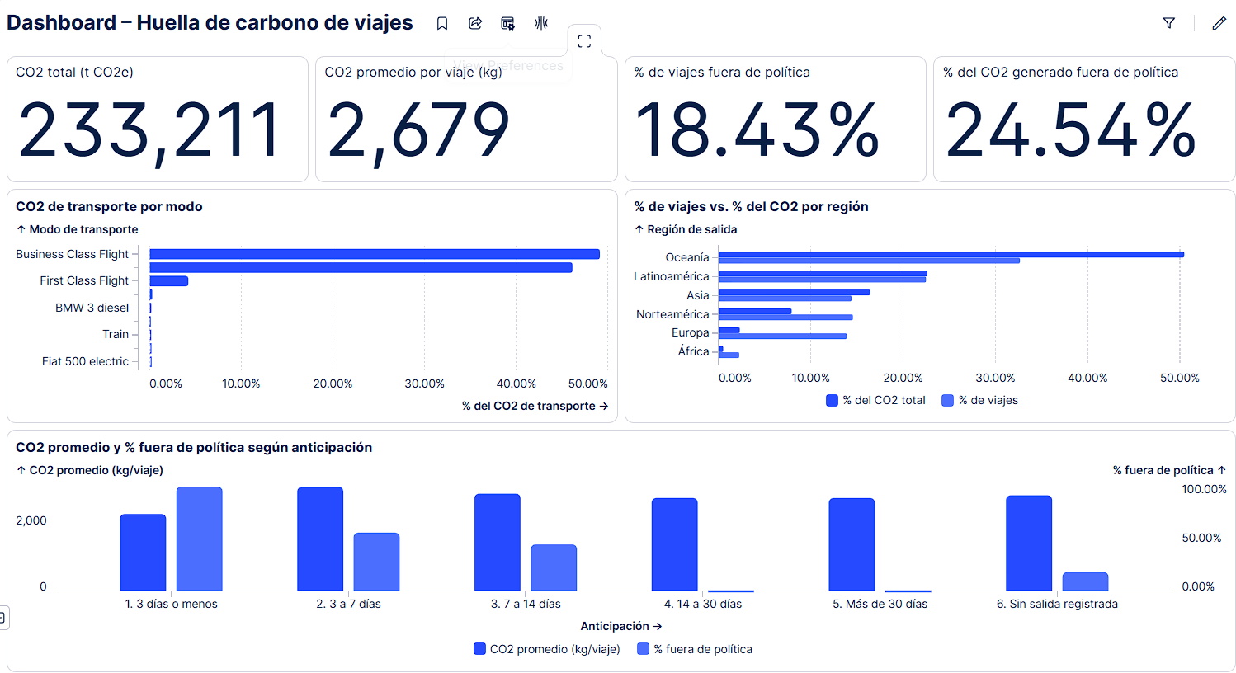
Fig. 2. Celonis dashboard “Carbon footprint of travel” (labels in Spanish).
Answer. H1 is confirmed. The footprint depends almost entirely on transport, so reduction efforts must focus on how transport is booked rather than on lodging. This figure is the baseline for tracking progress towards Net Zero 2030 (P3).

4.2 Q2: Regional Benchmarking
Hypothesis H2. North America has a worse carbon efficiency per trip than Europe, where land alternatives are more common, and the region with the most trips offers the greatest reduction potential.
Each trip was assigned to the region of its departure country. In the data there are only nine departure countries and ten departure cities (Sydney, São Paulo, Beijing, Berlin, Hamburg, New York, Mexico City, Cape Town, Madrid and Fukuoka), which represent the offices where trips are booked and approved. This matches the challenge question, which compares the company’s North American processes with those of Europe and Asia [1]; the arrival country, in contrast, reflects the destination, which the company does not control. Table 3 and Fig. 3 summarize the results.
Table 3. Emissions and transport mode by departure region (Celonis).
Region | Trips | % trips | % CO2e | kg CO2e per trip | % out of policy | % Business legs | % train legs
Oceania | 28,395 | 32.62% | 50.43% | 4,142 | 13.64% | 21.69% | 0.01%
Latin America | 19,533 | 22.44% | 22.58% | 2,696 | 11.68% | 20.25% | 0.00%
North America | 12,636 | 14.52% | 7.88% | 1,453 | 30.14% | 49.60% | 1.78%
Asia | 12,512 | 14.37% | 16.40% | 3,056 | 18.85% | 35.01% | 0.47%
Europe | 12,063 | 13.86% | 2.26% | 436 | 27.84% | 28.87% | 18.25%
Africa | 1,914 | 2.20% | 0.46% | 563 | 18.97% | 16.93% | 0.00%

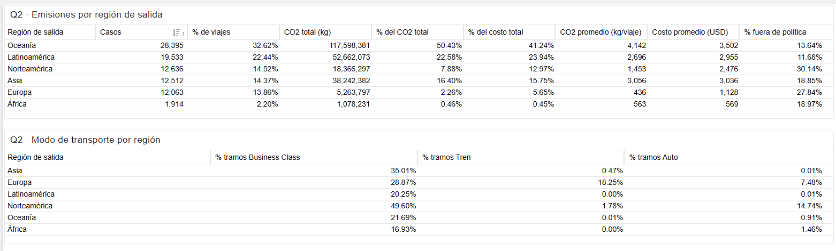
Fig. 3. OLAP tables by departure region in Celonis (labels in Spanish).
Two different situations appear. Per trip, North America emits 1,453 kg, 3.3 times more than Europe (436 kg), and Asia emits 3,056 kg, seven times more than Europe. Europe is the internal benchmark: 18.25% of its legs are by train and 7.48% by car. North America has the highest share of out-of-policy trips (30.14%) and almost half of its legs in Business Class (49.60%), which points to a booking behavior problem. Oceania, in turn, accounts for 32.62% of the trips but 50.43% of the emissions (4,142 kg per trip), a distance problem caused by intercontinental travel.
Industry comparison. To compare the case with the technology industry, we used the public reports of three software companies that disclose their business travel emissions (Scope 3, category 6 of the GHG Protocol [2]). Since the event log covers 570 days, the footprint of the case was annualized (233,211 t × 365 / 570 ≈ 149,300 t CO2e per year) and divided by the number of employees (Table 4).
Table 4. Business travel emissions of the case and of three technology companies.
Company | Period | Business travel (t CO2e) | Employees | t CO2e per employee
Case (annualized) | Dec 2023 – Jun 2025 | ≈ 149,300 | 70,240* | ≤ 2.13
Salesforce [7,8] | FY2025 (Feb 2024 – Jan 2025) | 148,000 | 76,453 | 1.94
Microsoft [9,10] | FY2024 (Jul 2023 – Jun 2024) | 260,000 | 228,000 | 1.14
SAP [11,12] | 2024 | 108,100 | 109,121 (FTE) | 0.99

* The case does not report total headcount; the number of distinct employees who traveled was used, so the value per employee is an upper bound.
The annualized footprint of the case is similar to that of Salesforce, higher than SAP’s and lower than Microsoft’s. Per employee, the case reaches at most 2.13 t CO2e per year, at the high end of the group (0.99 to 1.94 t). At SAP, flights represent 93.6% of business travel emissions [11], which is consistent with the dominance of air travel found in Q1. This comparison is indicative only, since fiscal periods and calculation methods differ, and the case data were adapted for academic purposes.
Answer. H2 is partially confirmed. North America is less efficient than Europe and concentrates the behavioral problem, where automated policy validations can deliver quick wins (P2). The region with the most trips, Oceania, does offer the largest absolute potential, but because of distance, so it requires long-term actions such as consolidating trips, replacing some of them with virtual meetings, and prioritizing Economy class on long-haul flights (P1, P3).

4.3 Q3: Low-Carbon Alternatives
Hypothesis H3. Premium classes (Business and First) generate a share of emissions larger than their share of legs.
Table 5 shows the distribution of legs and transport emissions by mode. Flights account for 94.16% of the legs and 99.33% of transport emissions. Business and First Class together represent 29.33% of the legs but 53.25% of transport emissions, whereas trains and cars together represent 5.84% of the legs and only 0.67% of emissions.
Table 5. Transport legs and emissions by mode.
Mode | Legs | % legs | % transport CO2e
Economy flight | 64,783 | 64.83% | 46.07%
Business Class flight | 27,665 | 27.69% | 49.06%
First Class flight | 1,639 | 1.64% | 4.19%
Train | 2,607 | 2.61% | 0.07%
Car (five models) | 3,231 | 3.23% | 0.60%

To identify concrete routes, a Celonis table compared, for each of the 60 routes (departure and arrival city of the leg), the number of flight and train legs and the average emissions of one Economy flight and of one train trip (Fig. 4). In 13 routes the company already uses the train, and in three of them (Hamburg → Berlin, London → Paris and Frankfurt → Paris) employees travel only by train. Table 6 shows the routes where both modes coexist.
Table 6. Routes where flights and trains coexist (kg CO2e per one-way leg).
Route | Flight legs | Train legs | Economy flight | Train | % Business flights
Berlin → Amsterdam | 814 | 1,007 | 88 | 27 | 17.69%
Berlin → Paris | 1,323 | 474 | 131 | 28 | 43.84%
Berlin → Madrid | 3,830 | 336 | 274 | 67 | 37.00%
Hamburg → Paris | 451 | 256 | 113 | 25 | 21.73%
Frankfurt → Berlin | 49 | 84 | 113 | 14 | 0.00%
Fukuoka → Tokyo | 298 | 65 | 131 | 22 | 13.42%
Berlin → London | 1,483 | 60 | 143 | 50 | 66.89%
New York → Toronto | 2,320 | 27 | 83 | 68 | 78.53%

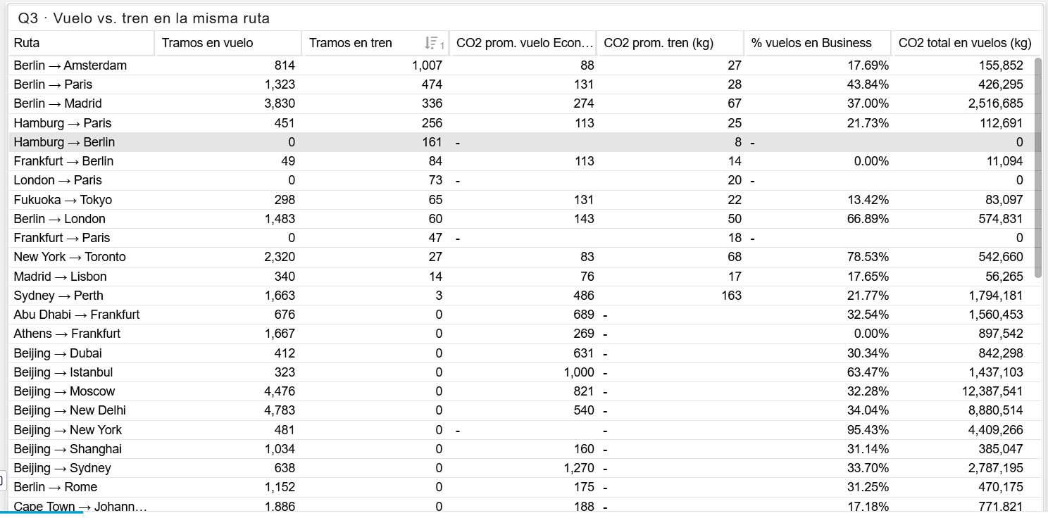
Fig. 4. Flight versus train on the same route, OLAP table in Celonis (labels in Spanish).
On European routes and on Fukuoka → Tokyo, the train emits between 3 and 8 times less than an Economy flight; on New York → Toronto the difference is small (68 versus 83 kg). As a reference scenario, if all flights on the seven short routes where the train is already used (Berlin → Amsterdam, Berlin → Paris, Hamburg → Paris, Frankfurt → Berlin, Fukuoka → Tokyo, Berlin → London and Madrid → Lisbon) were replaced by train, emissions would fall by about 1.1 million kg CO2e, close to 0.47% of the total. Some short routes also show an intensive use of Business Class, such as Berlin → London (66.89%) and New York → Toronto (78.53%).
Answer. H3 is confirmed. Three types of actions emerge. Replacing flights with trains on short routes is the most visible quick win and is easy to implement, but its total impact is small. Controlling the cabin class, especially on short routes and late bookings, has a much larger impact (see Q4). Finally, intercontinental routes, such as Beijing → Moscow (4,476 flights and 12.4 million kg CO2e), require long-term actions, since no land alternative exists (P1).

4.4 Q4: Out-of-Policy Trips and Emissions
Hypothesis H4. Out-of-policy trips emit more and cost more per trip than trips that comply with the policy, because late bookings lead to higher-emission options.
Table 7 and Fig. 5 compare both groups. The sum of their emissions (233,211,161 kg) matches the total of Q1.
Table 7. Weight and transport class of out-of-policy trips (Celonis).
Out of policy | Trips | % trips | % CO2e | % costs | kg CO2e per trip | Cost per trip (USD) | % Business legs | % Economy legs
No | 71,010 | 81.57% | 75.46% | 72.97% | 2,478 | 2,478 | 19.59% | 73.56%
Yes | 16,043 | 18.43% | 24.54% | 27.03% | 3,567 | 4,063 | 65.49% | 24.08%

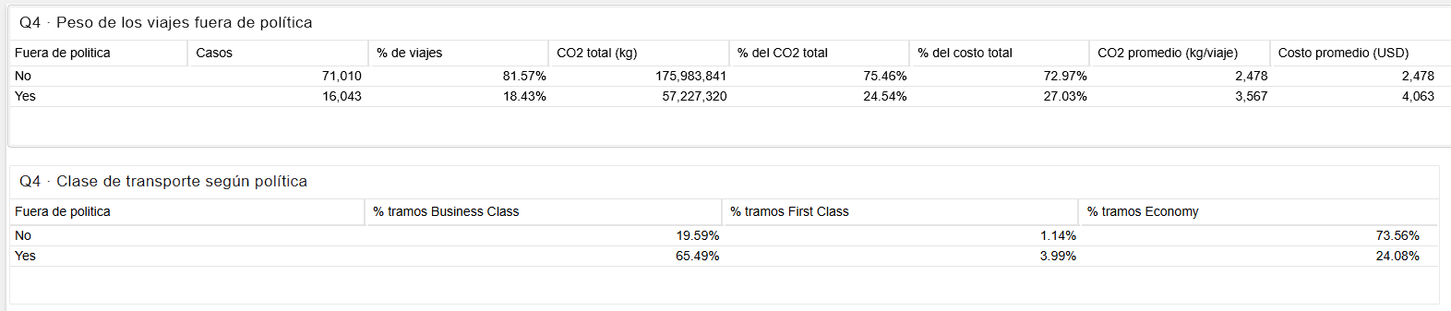
Fig. 5. Out-of-policy trips and transport class by policy status in Celonis (labels in Spanish).
Out-of-policy trips represent 18.43% of the trips but generate 24.54% of the emissions and 27.03% of the costs. Per trip, they emit 43.9% more (3,567 versus 2,478 kg) and cost 64.0% more (USD 4,063 versus USD 2,478). The main mechanism is cabin class: 65.49% of their legs are in Business Class, compared with 19.59% for compliant trips. As a theoretical ceiling, if the 16,043 out-of-policy trips had the average emissions and costs of compliant trips, the company would avoid about 17.47 million kg CO2e (7.49% of the total) and USD 25.4 million.
Answer. H4 is confirmed. Out-of-policy trips are a disproportionate source of emissions and costs, mainly because of premium classes. This supports automated policy and class validations (P2), showing the additional CO2e at booking and approval time (P1), and monitoring the share of emissions generated outside the policy (P3).

4.5

5 Discussion and Recommendations

6 Conclusions

References
- Celonis: Sustainability Project: Decarbonizing Travel. Process Intelligence Challenge case, adapted for the course IF6201 Informática Aplicada a los Negocios II, University of Costa Rica (2026)
- World Resources Institute, World Business Council for Sustainable Development: Technical Guidance for Calculating Scope 3 Emissions, version 1.0. Greenhouse Gas Protocol (2013), https://ghgprotocol.org/sites/default/files/2022-12/Chapter6.pdf
- van der Aalst, W.M.P.: Process Mining: Data Science in Action, 2nd edn. Springer, Heidelberg (2016)
- van der Aalst, W.M.P., et al.: Process Mining Manifesto. In: Daniel, F., Barkaoui, K., Dustdar, S. (eds.) BPM 2011 Workshops. LNBIP, vol. 99, pp. 169–194. Springer, Heidelberg (2012)
- van Eck, M.L., Lu, X., Leemans, S.J.J., van der Aalst, W.M.P.: PM²: A process mining project methodology. In: Zdravkovic, J., Kirikova, M., Johannesson, P. (eds.) CAiSE 2015. LNCS, vol. 9097, pp. 297–313. Springer, Cham (2015)
- Celonis: Celonis Documentation, https://docs.celonis.com
- Salesforce: FY25 Schedules of Selected Environmental and Employee Metrics (2025), https://www.salesforce.com/en-us/wp-content/uploads/sites/4/documents/white-papers/fy25-schedules-of-environmental-and-employee-metrics.pdf
- Salesforce: Form 10-K for the fiscal year ended January 31, 2025. U.S. Securities and Exchange Commission (2025), https://www.sec.gov/Archives/edgar/data/1108524/000110852425000006/crm-20250131.htm
- Microsoft: 2025 Environmental Sustainability Report – Data Fact Sheet (2025), https://cdn-dynmedia-1.microsoft.com/is/content/microsoftcorp/microsoft/msc/documents/presentations/CSR/2025-Microsoft-Environmental-Data-Fact-Sheet-PDF.pdf
- Microsoft: Form 10-K for the fiscal year ended June 30, 2024. U.S. Securities and Exchange Commission (2024), https://www.sec.gov/Archives/edgar/data/789019/000095017024087843/msft-20240630.htm
- SAP: SAP Integrated Report 2024 – Environmental Data (2025), https://www.sap.com/integrated-reports/2024/en/datahub/environmental-data.html
- SAP: SAP Integrated Report 2024 – Social Data (2025), https://www.sap.com/integrated-reports/2024/en/datahub/social-data.html

